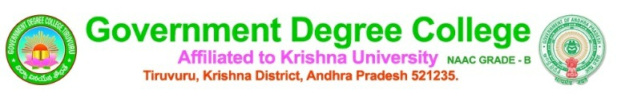

**Performance of the Institution**

1.Gender sensitization is the area of priority in the institution : Grievance Redressal Committee, Anti Ragging Committee plays crucial role in promoting gender equality and in preventing disparity, harassment, ragging . These committees in collaboration with statutory bodies such DISHA committee, Integrated Child Development Services (ICDS) Cyber Mitra organizes senstitization and Anti Drug and Girl Trafficking programmes to turn the campus into safe place for learning with zero tolerance.

Implementing the Guidelines of Statutory body 2019-20

**Display of Posters of Ragging & Punishments, DISHA ACT by Grievance Redressal and Anti ragging Committee Members on 29.1.2020**

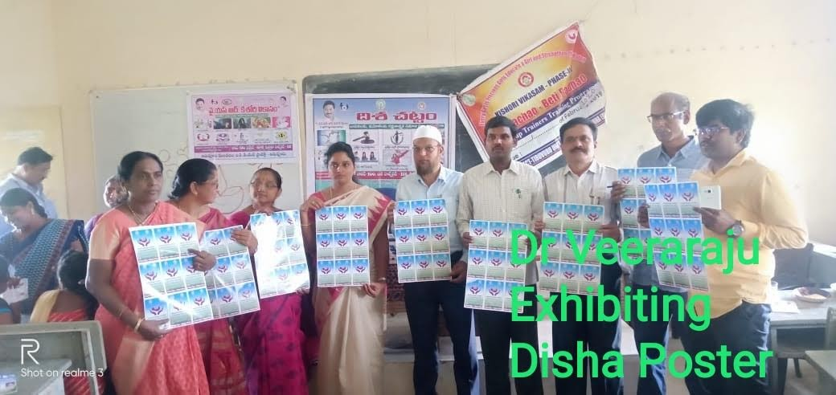

**CPDO of ICDS educates students on women protection statutory bodies and helpline numbers on 29.1.20**

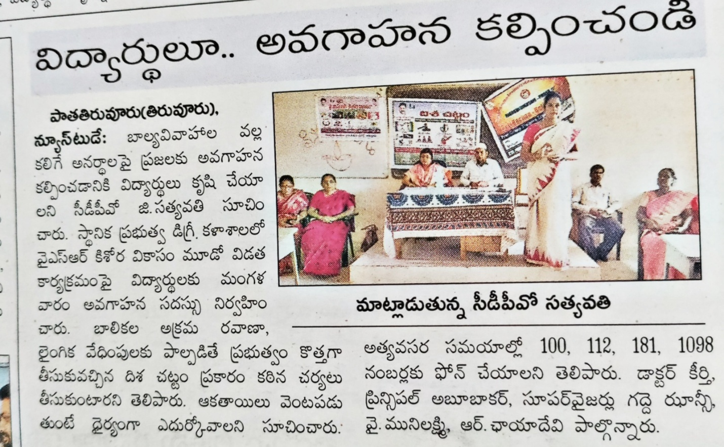

Implementing Guidelines of Statutory body-2020-21

CI Satyanarayana speaks on punishment for Ragging on 19.12.20 in awareness programme

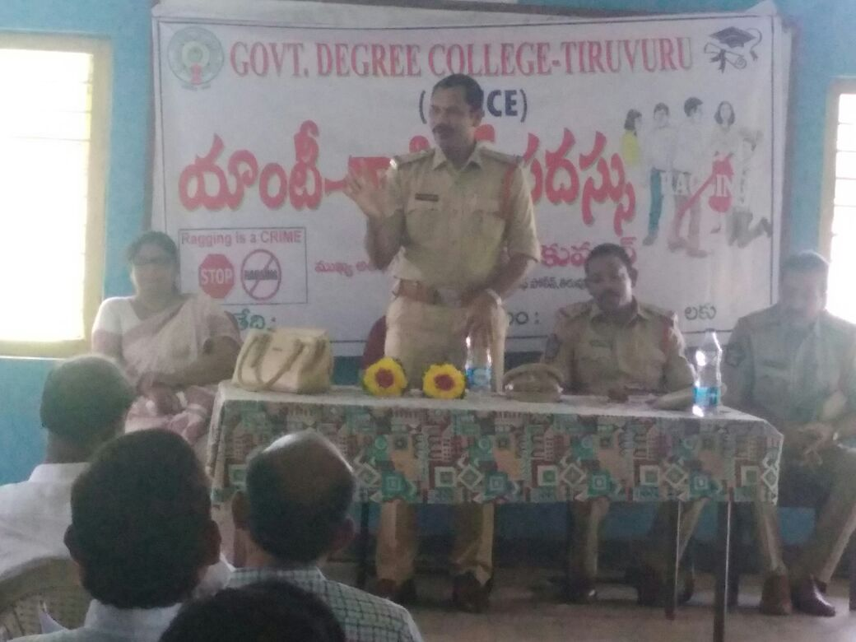 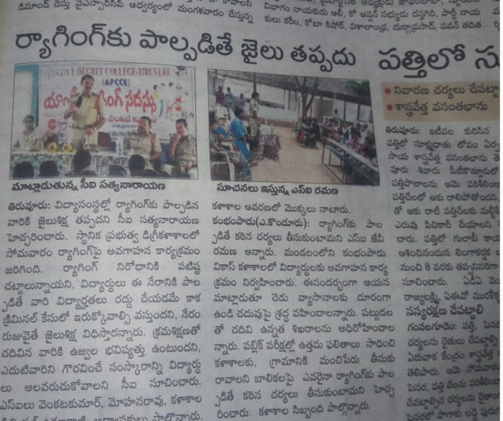

Implementing Guidelines of Statutory body-2021-22

Organized an Anti Drug Awareness programme on

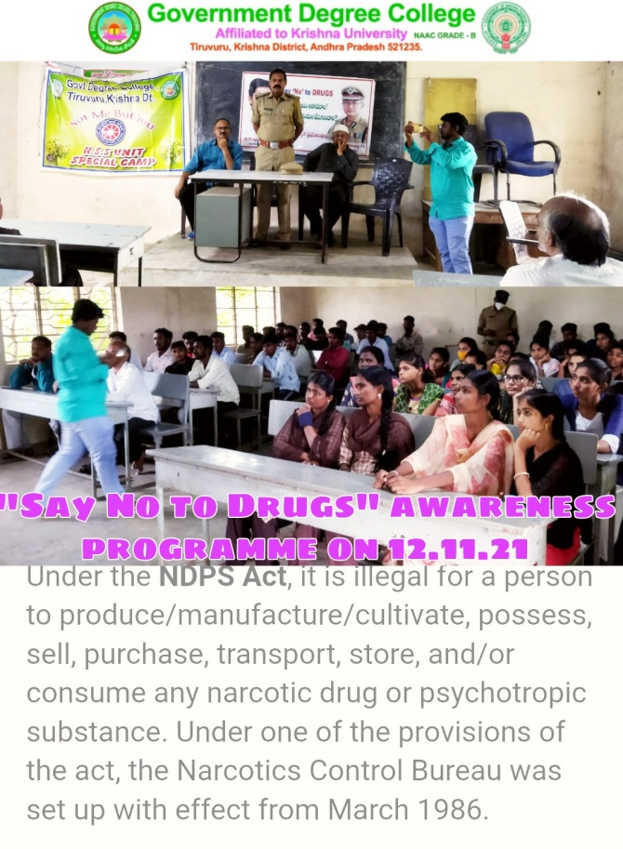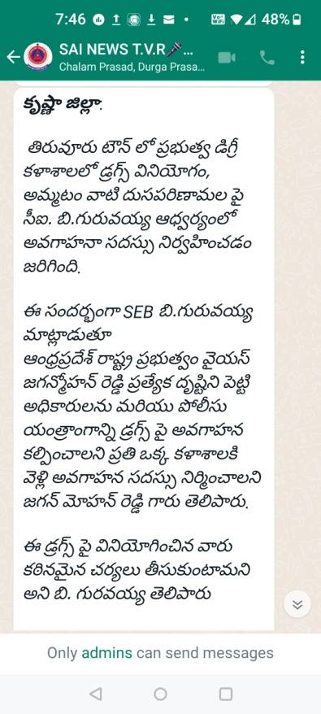

Implementing Guidelines of Statutory body-2022-23

Organized a gender sensitization programme on 17.12.22

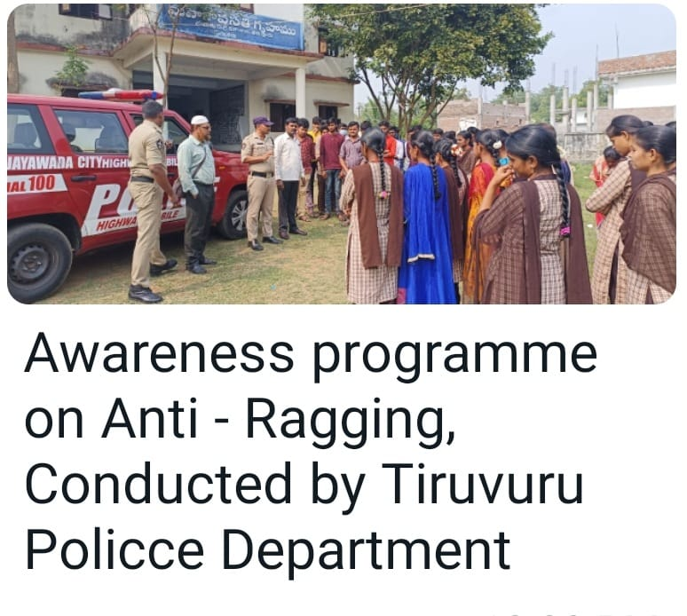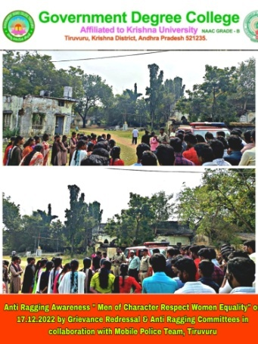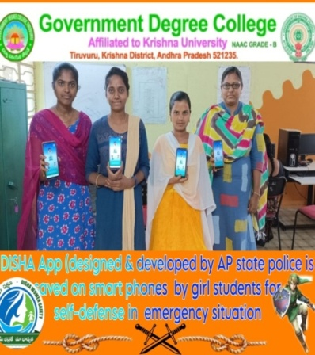

Implementing Guidelines of Statutory body-2023-24

Organized a gender sensitization programme on 13.10.2023

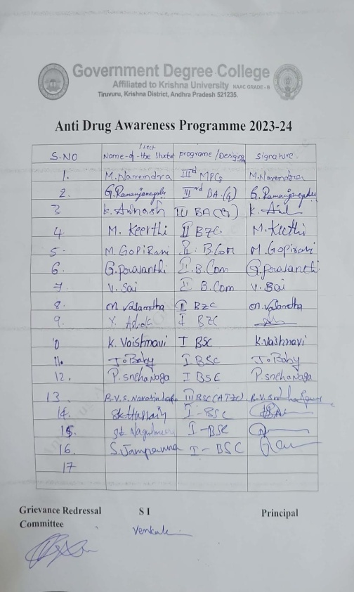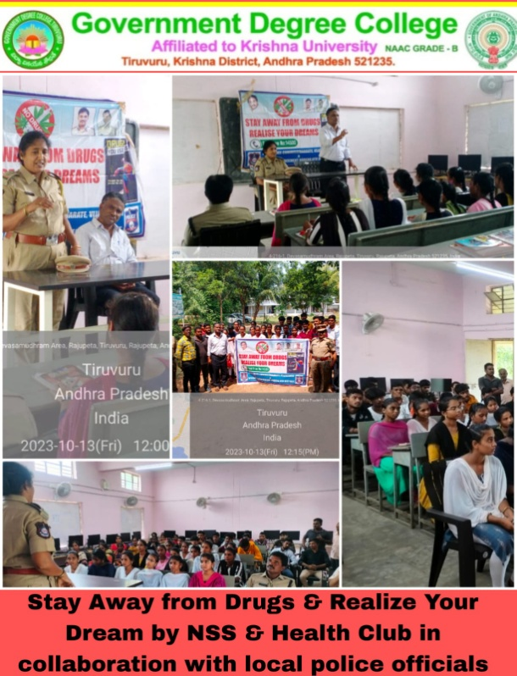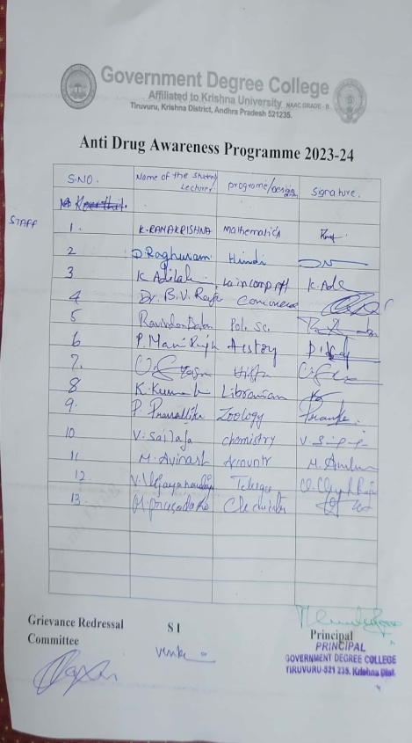

Inclusive Environment

in GDC Tiruvuru Pongal Celebration

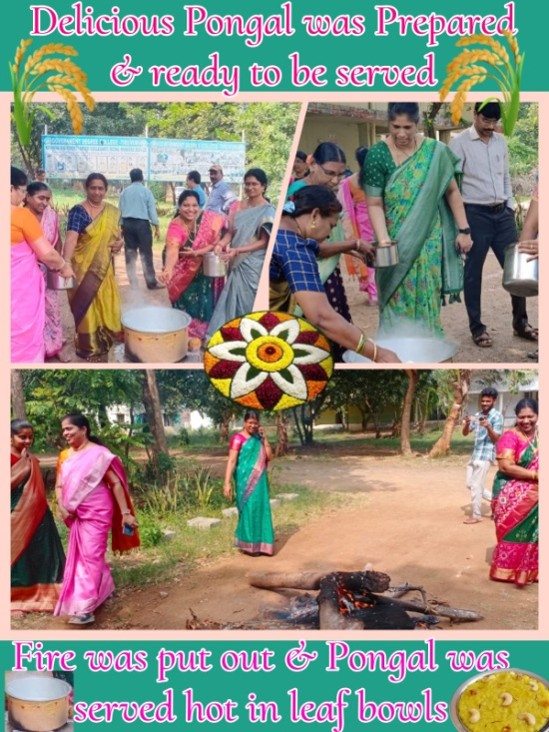 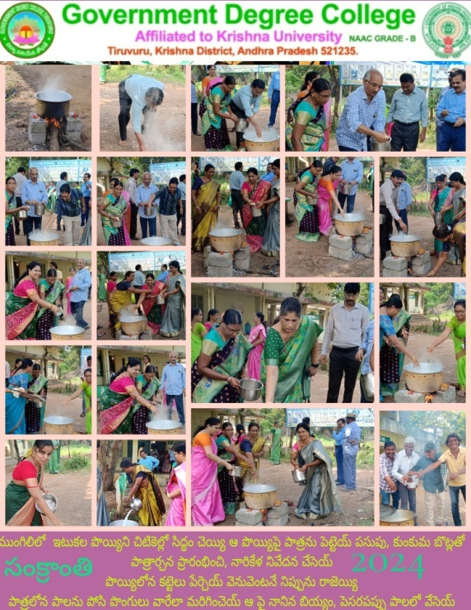 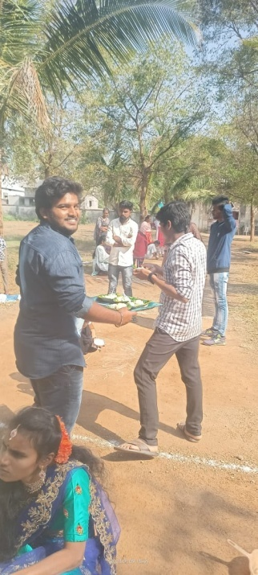

Clean Campus by NSS Unit In 2023-24 on 18.10.23

on 3.11.2021

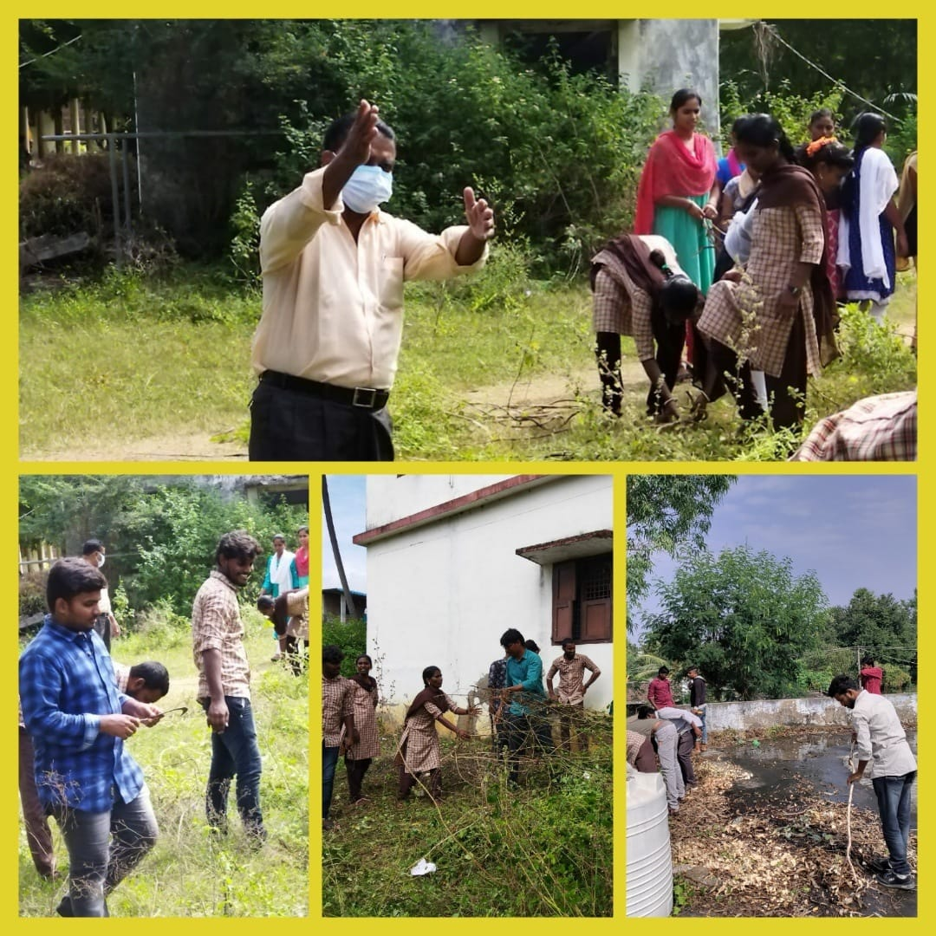 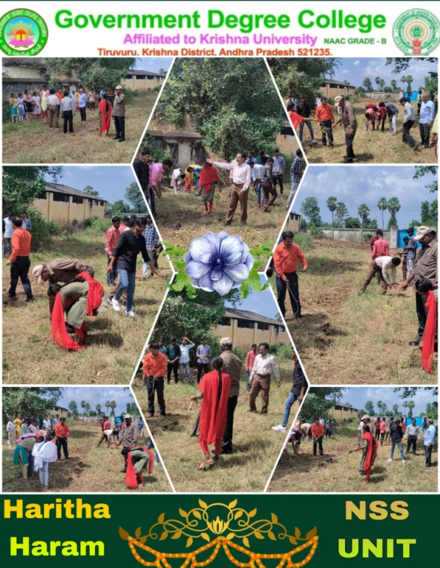

In Neighbourhood on 17.9.22 Public Charity on 25.4.20

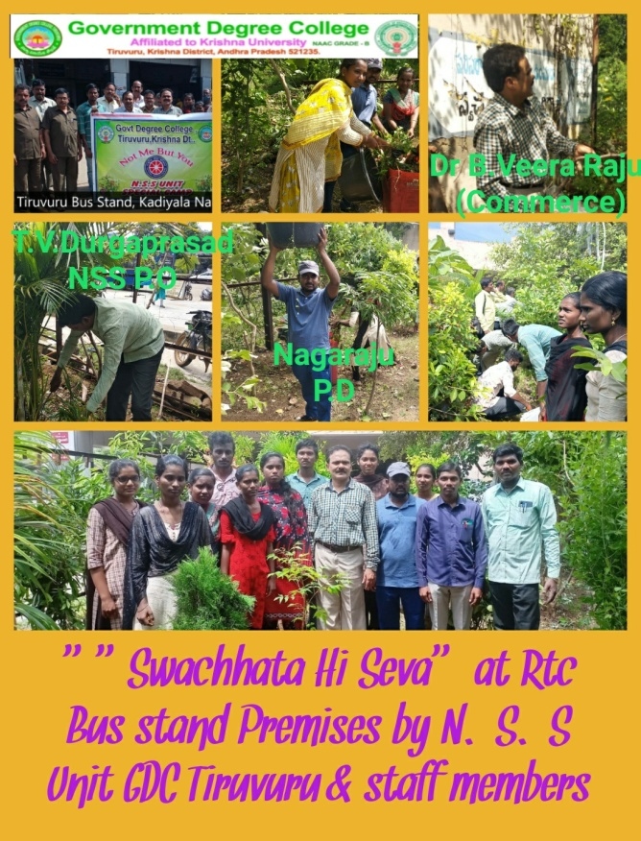 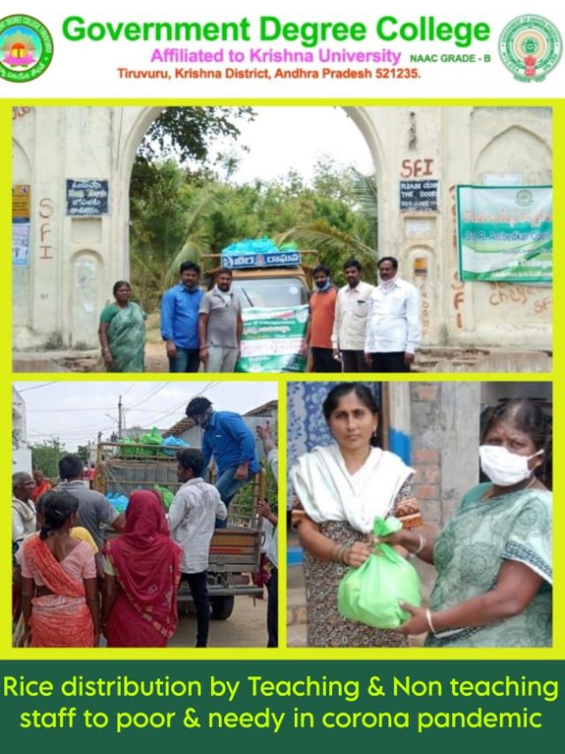

Adopting ICT Methods for Online Teching to cope with

Quality in Education Crisis and continue teching

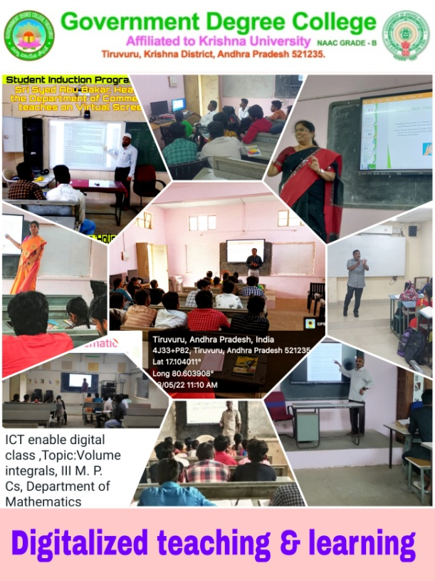 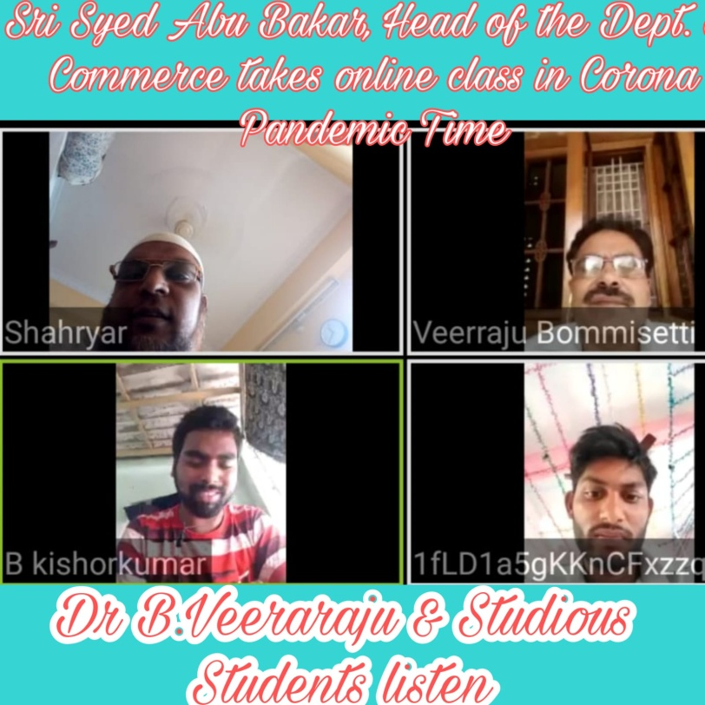

Staff doing online courses like Swayam for professional Development

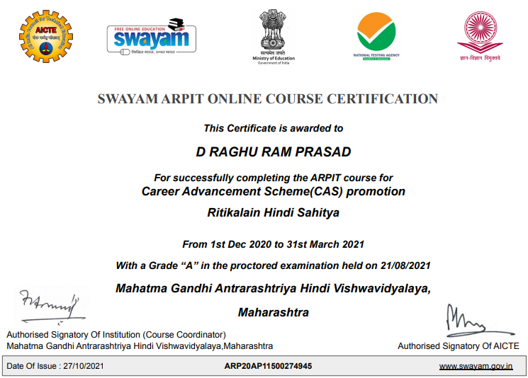 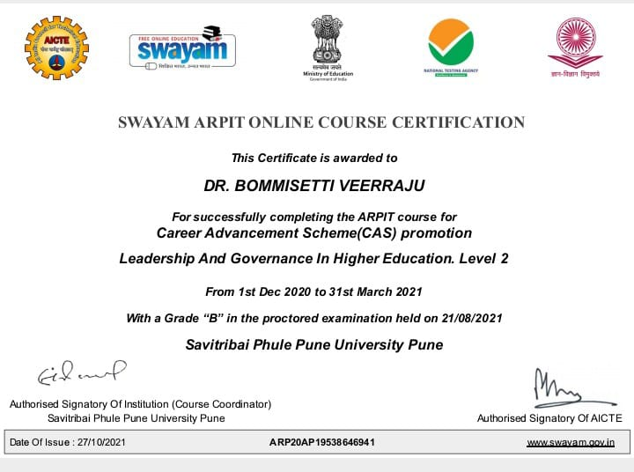

Cash Prize of Rs.10,000 to M.Sireesha, Advanced Learner

By Sri K.Mutya Prasad, Lawyer on 20.11.2023

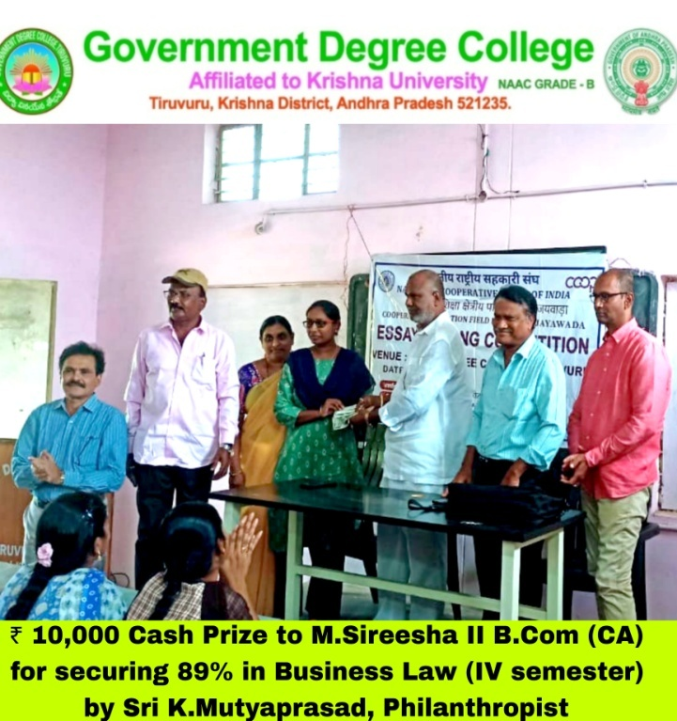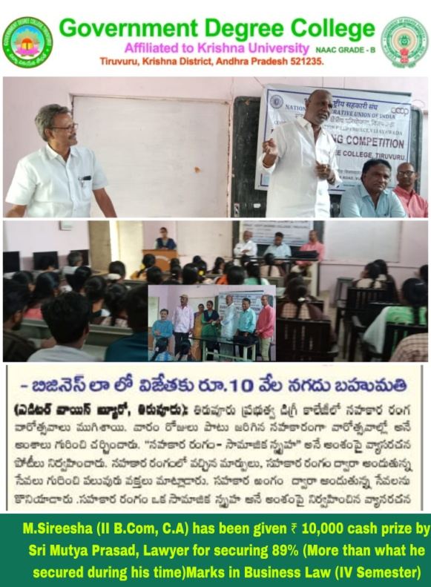

**Health Camp organized by Health Club for Community Health Care**

**On 18th & 19th October, 2023**

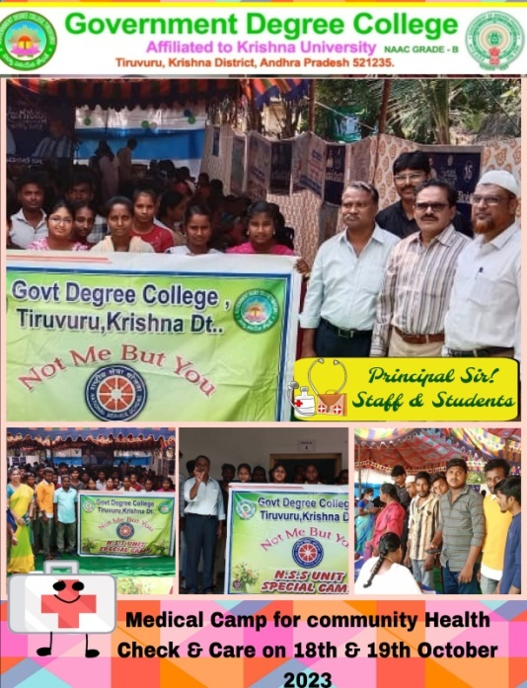 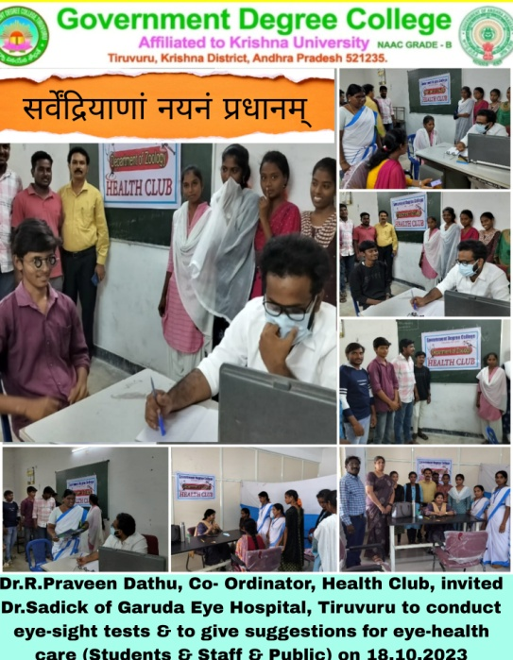

Girl students were taken to Mahila Utsav,Vijayawada to draw inspiration from upcoming women entrepreneurs on 7.3.2023

